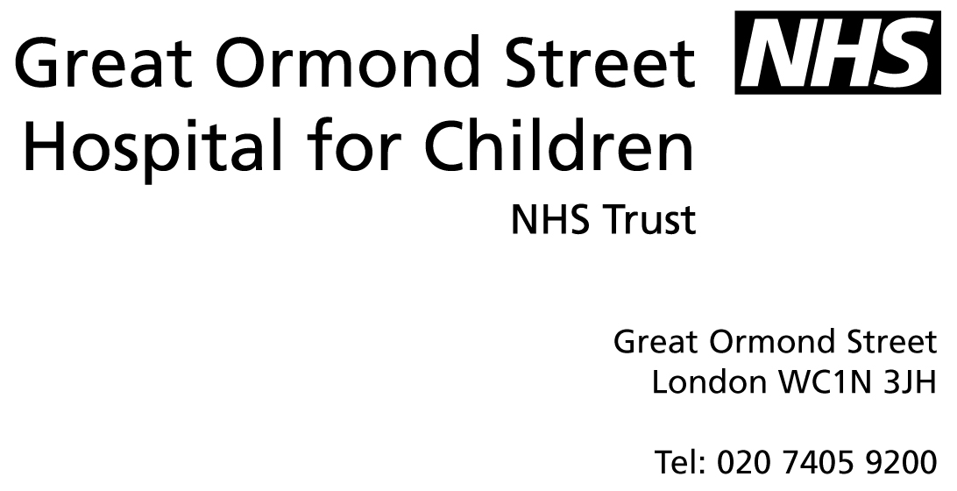
_

The National Study of Steroid Resistant Nephrotic Syndrome in Childhood

Information Sheet for Parents or Guardians

Researchers
Dr Hugh McCarthy and Professor Moin Saleem
Academic Renal Unit
University of Bristol, Southmead Hospital Campus
Southmead Road
Bristol
BS10 5NB
0117 959 5438

Your child is being invited to participate in a research study. Before you decide, it is important for you to understand why the research is being done and what it will involve for you and your child.
Please take time to read the following information carefully and discuss it with others if you wish. If appropriate, please encourage your child to read their information sheet and discuss the study with them.
Your child’s kidney specialist will explain if there is anything that is not clear or if you would like more information. Thank you for taking the time reading this.

The purpose of this study
Your child’s kidney specialist has made a diagnosis of Steroid Resistant Nephrotic Syndrome (SRNS) or Focal Segmental GlomeruloSclerosis (FSGS). The cause of this is rarely known and it can be very difficult to treat. The treatment itself can have side effects and appears to be more effective in some than in others.
Unfortunately, some patients with SRNS/FSGS go onto develop kidney failure and require a kidney transplant. In that case, there is a chance that the disease can return to affect the transplanted kidney.
For this reason the kidney research unit in Bristol has developed a special interest in SRNS/FSGS and what happens to the kidney in this disease. They want to find out if some children are prone to developing the disease because of gene mutations. Our genes sit in all the cells of the body and hold the information to developing and maintaining the cells. If the programming of the gene is slightly altered this results in a ‘gene mutation’ which can result in a disease. We know that there are some gene mutations which cause FSGS in childhood but we don’t know how often this occurs in children in the UK.
The research group also proposes to find out about how the disease actually affects the kidney, especially after transplantation, and whether it causes a pattern of changes in the kidney cells which is the same in every patient.

Why has my child be chosen?
The research team, although based in Bristol, are approaching the family of every child with steroid resistant nephrotic syndrome or FSGS, in the United Kingdom.

Does my child have to take part?
It is up to you to decide whether you take part. If you do decide to take part you will be asked to sign a consent form. You are still free to change your mind and withdraw at any time without giving a reason. If you decide not to take part or to withdraw from the study this will not affect the treatment you receive.

What will happen if my child agrees to take part?
There are four parts to this study:
Firstly, when your child next has a blood test, a little extra blood will be taken. The amount of blood to be taken is 5mls. The additional sample will be sent to the research laboratory in Bristol so that it might be tested for genes, which may be related to SRNS/FSGS in childhood.
Secondly, the research group will review your child’s medical details from the rare kidney disease database, RaDaR if you have previously consented to the details being placed onto this. This is anonymous and the researchers will not know your name or address and will not make contact with you directly.
Thirdly, should your child undergo kidney transplantation, during routine blood tests immediately before and 24hours after the transplantation a little extra blood would be taken to be sent to the research group, along with a urine sample.
Lastly, if your child underwent transplantation and the disease returned in the transplanted kidney, they are likely to undergo a treatment called ‘plasma exchange’. During this treatment your child’s plasma is exchanged for new plasma and the original plasma is discarded. In this study samples of the discarded plasma would be sent to the research group.
The tests on the blood, urine and plasma are to see whether they contain factors which cause patterns of disease similar through all the patients.

What will happen to any information about my child?
The information that has been or will be collected by the RaDaR study is stored on a secure web server. The research group has signed a confidentiality agreement with the RaDaR group and will have access to the clinical data during the time period of the study but not the personal information. At the end of the study the research group will no longer have access and the RaDaR group will continue to store it securely.

What will happen to my child’s samples?
All samples will be kept in the University of Bristol Academic Renal Unit. The samples are anonymous and will be only be identified by a RaDaR code number. Access to this building is limited to the research staff and an identification card is required. The samples are stored in a freezer at minus 80degrees until they are required.
At the end of the study the samples will continue to be stored in the Academic Renal Unit pending further study.

How will I know the outcome of the research
We expect that about 20% of children tested will have a gene mutation identified which may not have been known about previously. Any results on genetic testing will be fed back to your child’s kidney specialist (if you consent to this) who will talk to you about the result. If a gene mutation is found, information on this gene and what it means for your child and your family will be provided to your local team to feed back to you. Also on the RaDaR website, information on each of the genes being tested will be uploaded and kept up to date as new information is found. You will have access to this information.
The data and other tests will be collated and published and your specialist will explain the findings to you.

Will my GP know about this research?
Yes, if you wish. Your specialist will send an information sheet about the study to your family doctor and inform him or her of any results from the study.

Can I have more time to decide?
Yes. There is no time limit. You can discuss this research proposal with anyone you choose. You may also have a copy of the full research proposal if you wish. Your child’s kidney specialist will give you a copy.

What if I wish to withdraw?
A patient may withdraw at any stage without having to give explanation. You can do this in writing to your local kidney doctor or to the research team directly if you wish. The results of any tests on samples already collected will be used but no further tests will be done on these samples and no further samples will be collected. Any samples held by the research team will be destroyed in an appropriate manner.

What if new genes are discovered that can cause SRNS/FSGS?
The research-group proposal includes testing for all the genes currently known to cause FSGS in children. However there are probably more that are not yet known. Were new genes to be identified, then the group will test the original samples for the new genes.

What are the risks/benefits in participating in this study?
This study does not require you to attend hospital more frequently or for your child to undergo extra procedures, only to have more blood taken at the next opportunity. The benefits are to increase the medical knowledge about this disease which we really need to know more about. If a gene mutation is identified it will provide some explanation as to why your child became unwell.

What do I do if I have concerns about the study?
If you have any concerns or further questions about this study or the way it is carried out, you should contact your child’s kidney specialist (the local investigator) in the first instance. You can also contact the PALS service of the hospital where you are being treated.

Has this research study been approved by an ethics committee?
This study has been approved by the North Somerset and South Bristol Research Ethics Committee, reference number 09/H0106/80.

